Contract Area | Coordinates
South Deepwater Tano Block | 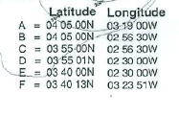
East Cape Three Points | 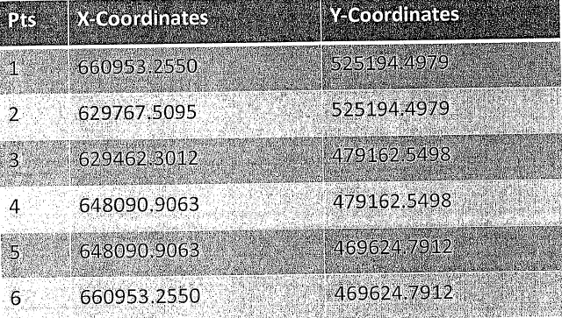
Deepwater Tano | 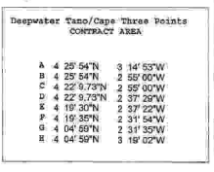
Deepwater Tano Cape Three Points | 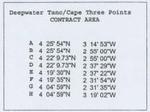
West Cape Three Points | 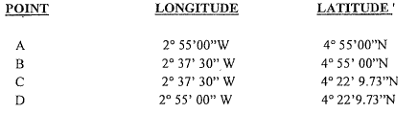
Saltpond Oil and Gas Field | 